Dashboard Design - Tableau
Date | 29 October 2026
Team ID | Individual Project - Ujjawal Rathod
Project Name | Electric Vehicle Market Performance & Insights
Maximum Marks | 5 Marks

Dashboard objective
Create a single decision-support dashboard with nine coordinated worksheets for EV sales, competitive landscape, technology adoption, range, satisfaction, and geography. Keep the Overview dashboard as the navigation anchor for the four-point Tableau Story.
The image below is a design mock-up rather than a capture of the published Tableau workbook. Use the existing Tableau Public link for the live dashboard and capture current screenshots from that workbook for formal evidence.
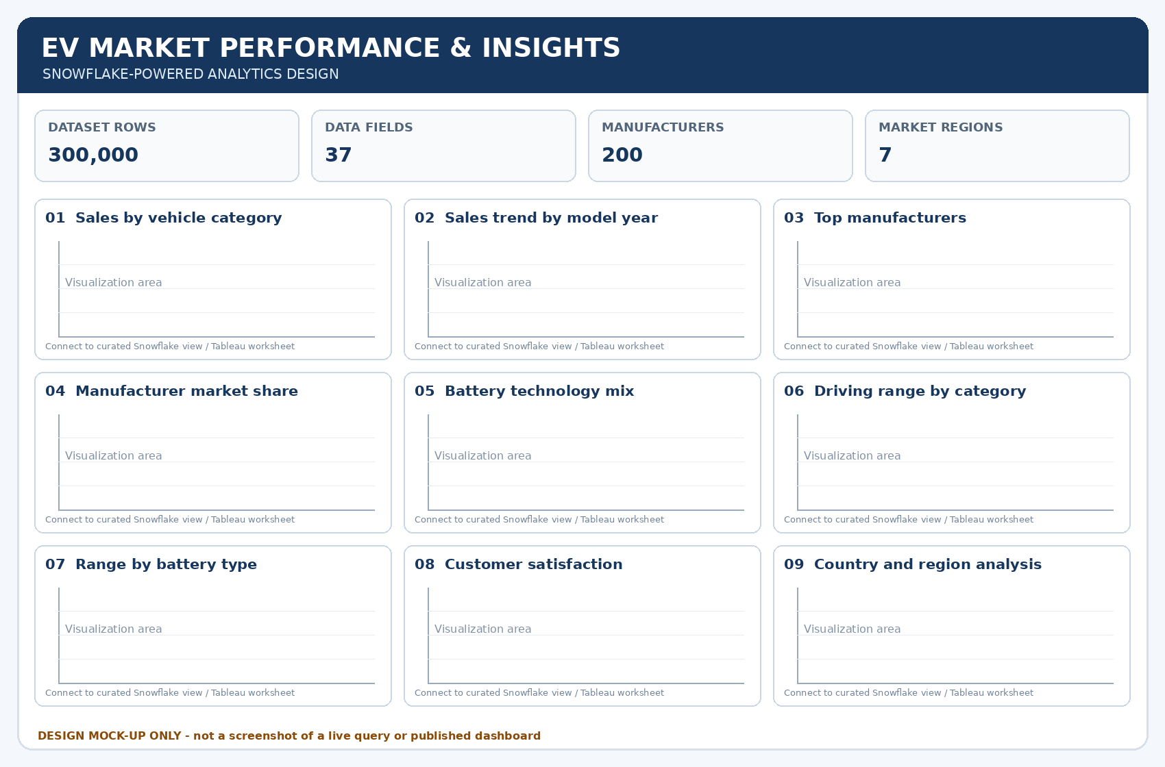

Design specification
Design element | Implementation | Reason
Header and KPI row | Project title, 300k-row source summary, 37 fields, 200 manufacturers, 7 regions | Sets scope and orients the reader; confirm row count from actual data source.
Sales visual group | Sales by vehicle category, sales trend by model year, regional sales | Answers demand and portfolio questions first.
Competitive visual group | Top manufacturers and market-share view | Shows fragmentation without hiding the long tail.
Technology / experience group | Battery mix, range by category, range vs energy use, customer rating | Compares technology adoption and user outcomes.
Geography | Manufacturing country x market region heatmap | Separates manufacturing origin from market destination.
Filters and actions | Model Year, Region, Battery Type, Category; dashboard filter actions on relevant charts | Lets stakeholders test scenarios while retaining context.
Formatting | Consistent units, concise titles, visible zero baselines where appropriate, accessible contrast, descriptive tooltips | Improves trust and interpretation.
Layout | Overview page optimized for desktop; scrolling layout only where necessary; legends placed beside related charts | Avoids crowded visual clutter and supports presentation walkthroughs.

Major outcomes / observations to confirm
• Two-Wheeler Scooter is identified as a leading sales category in the prior project summary.
• Market share is highly fragmented; the leading manufacturer was previously summarized at about 0.6% of total market sales.
• NMC and LFP are the two leading battery chemistries in the earlier summary.
• Range differs markedly by category, while average range by chemistry was described as comparatively flat across 2018-2026.
• Average customer ratings were summarized at approximately 4.08-4.09/5 across categories.
• Manufacturing and regional views should use clearly labelled country/region fields and include tooltips for totals.
Published Tableau Public Story / Dashboard: https://public.tableau.com/app/profile/ujjawal.rathod4051/viz/ElectricVehicleMarketPerformanceInsights_17931389708610/EVMarketStory

